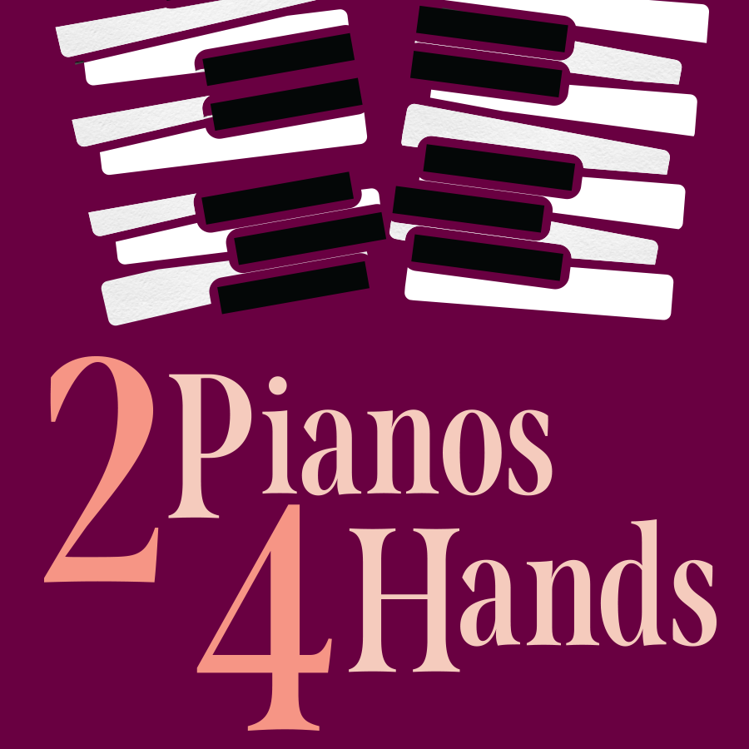

ACCESSIBILITY GUIDE

GUIDE INTRODUCTION

Welcome to Northlight’s production of 2 Pianos 4 Hands by Richard Greenblatt and Ted Dykstra.

This production will run at Northlight Theatre from July 5 through August 4, 2024. The address is 9501 Skokie Blvd, Skokie, IL, 60077.

This guide holds many different accessibility tools to make your experience at the show as comfortable as possible. Please be aware that not every element of this guide will be useful to each individual. Therefore, please feel free to pick and choose which accessibility tools would be most beneficial to you.

TABLE OF CONTENTS

Performance Schedule | Page 3
Synopsis | Page 4
Sensitivity Guide | Page 9
Frequently Asked Questions | Page 10
Reference Photos | Page 12

PERFORMANCE SCHEDULE

Tuesday – Saturday Evenings (all times are estimates)
6:30pm The lobby opens for concessions & socializing.
7:00pm The auditorium opens for you to take your seat.
7:30pm The show will begin.
8:20pm A 15-minute intermission will begin.
8:35pm Intermission will end, and you can return to your seat.
9:40 pm The show will end.

Saturday – Sunday Matinees (all times are estimates)
1:30pm The lobby opens for concessions & socializing.
2:00pm The auditorium opens for you to take your seat.
2:30pm The show will begin.
3:20pm A 15-minute intermission will begin.
3:35pm Intermission will end, and you can return to your seat.
4:40pm The show will end.

Weekday Matinees (all times are estimates)
12:00pm The lobby opens for concessions & socializing.
12:30pm The auditorium opens for you to take your seat.
1:00pm The show will begin.
1:50pm A 15-minute intermission will begin.
2:05pm Intermission will end, and you can return to your seat.
3:10pm The show will end.

FULL SHOW SYNOPSIS
(spoilers ahead)

Please note that the following was created during a preview performance. It is possible that changes to the script and/or production may not be reflected below.

Run time: 2 Hours and 10 Minutes, with one 15-Minute Intermission

Act I
In the opening scene of the play, Ted Dykstra and Richard Greenblatt, two performers dressed in concert attire, take the stage, set with two magnificent grand pianos. As they prepare to perform, there are a few awkward exchanges as they trade pianos and adjust their benches, apologizing to the audience. Finally, they begin to play Bach’s Concerto in D Minor as a duet, until suddenly, they become out of sync, and the piece grinds to a halt.
They begin to trade competing scales, which grow in intensity and complexity, then join forces in a glorious explosion of octaves. They then play the plunking beginning of “Heart and Soul,” riffing on it in different styles and keys, before transitioning into “Chopsticks” and the “Knuckle Roll Song,” and finishing with a simple scale to conclude their opening duet.

In the next sequence, Ted and Richard trade off, inhabiting each others’ childhood piano teachers. We see Ted become Richard’s first piano teacher, Sister Loyola. She quizzes him on minor and major keys, using idiosyncratic teaching methods and many humorous acronyms before going upstairs for a cup of tea and a lie-down.

We also see Ted’s piano teacher, Mr. Berkoff. He sternly explains time signatures to Ted, having him count out loud while playing. Ted transforms into yet another piano teacher, Mr. Morton, who teaches Richard about fingering, leading to a marked improvement in his playing. Richard and Ted both begin to develop a love for playing the piano.

Ted winds a metronome, which ticks at 138 beats per minute. Ted and Richard both begin to experience the tedium of constant practice, hounded by their respective parents to practice every day. They express the desire to hang out with friends, watch TV, and get snacks, but ultimately continue to practice piano despite their frustrations.

Richard’s father (played by the actor who plays Ted) hears him play “Shave and a Haircut,” and chastises him for not taking his practicing seriously. They argue; Richard chafes under his father’s overbearing coaching, while Mr. Greenblatt thinks his son should be grateful that he is pushing him to excel. He calls Richard’s piano teacher, Mrs. George, threatening to tell her that Richard wants to quit the piano, but when he passes the phone, Richard declines to quit. The two make a pact that if Richard is to continue playing, he will have to practice one hour every single day until he is seventeen. However, Mr. Greenblatt has to promise not to help him or bother him in any way. They shake hands, closing their deal.

10-year-old versions of Ted and Richard meet to practice the Mozart duet they are performing in an upcoming piano competition. They bicker and trade insults, personalities clashing. While practicing the piece, they physically compete for space, pushing each other off the bench and resorting to childish slaps, punches, and ‘wet willies’ to gain the upper hand.

At the Kiwanis Club’s Eleven-and-Under Piano Competition, Ted and Richard are introduced by the judge, Bela Nagy, who announces that they will perform “In the Hall of the Mountain King” by Edvard Grieg. As they begin to play, Ted is struck with stage fright and can’t remember the music he’s supposed to play. Richard gets their sheet music from his mom, but it falls on the floor. It’s a disaster. Richard attempts to play both parts, with Ted turning pages, until it becomes too much, and they play together, both struggling and on the verge of tears.

We find Ted again at his Conservatory of Music grade seven piano examination. The examiner asks him to play various scales, increasing in difficulty, and he does so, nervously. When they get to a scale he doesn’t know, the examiner tells him that while he has talent, he does not have a good teacher in Mr. Berkoff, and that he needs a new teacher if he is serious about playing. The exam continues, and we see both Ted and Richard answering rapid-fire questions on music history and theory.

The two pianists meet again for the first time since the previous year’s competition, as they sign up for this year’s contest. They will compete against each other, playing much of the same repertoire, including Bach’s Concerto in D Minor. Both are secretly intimidated by the other, and they throw themselves into practice.

Act II
We return to Ted and Richard in piano lessons again, this time with new teachers. They receive conflicting advice on whether to play arpeggios with one or two hands, and which method would attract more women.

At home, Ted’s father praises his playing, but he wonders if Ted’s obsessive practicing has inhibited his social development. Ted has few friends, rarely goes outside, and his grades are slipping. Mr. Dykstra wonders how Ted will get into university; Ted retorts that he has no need to go to university, as he plans to become a professional musician. He wants to go to Juilliard. Ted inadvertently calls his father a failure, which causes his father to give him an ultimatum: get an eighty percent grade point average and attend a good university, or Mr. Dykstra will ban Ted from music lessons and sell the piano.

Starting from a point of frustration, Ted and Richard trade piano melodies back and forth, moving from classical to jazz to rock and roll, concluding with Ted jamming out on his own.

Ted’s jam session is interrupted by Richard, playing a teacher, who scolds him for fooling around while waiting to audition for a conservatory. The teacher proceeds with the audition, and after Ted fails to meet to his demands, tells Ted that he is a lazy, arrogant, teenager who does not have what it takes to be a classical pianist. While Ted may have talent, he doesn’t have the discipline to truly succeed. Ted is devastated.

Richard goes to a jazz audition after becoming disillusioned with the classical world. He says he’s been writing some of his own blues music. However, he is out of his depth in the jazz world. He is told to run back to classical music.

At seventeen, Ted teaches beginner piano lessons to an older woman named Marsha, who is an emotional mess, and Richard plays Piano Man in a bar for unappreciative customers. Neither is happy. In a final lesson with his teacher, a cynical Richard declares that he’s quitting the piano.

Ted and Richard drink beer together, listening to Vladimir Horowitz’s Carnegie Hall performance of Liszt’s Mephisto Waltz on tape. Ted laments that they could have been great, but that they lacked discipline. Richard remarks that he makes this speech every time they get drunk together, but reminds Ted that though they might not be the best in the world, the country, or even the city, they are two of the best piano players in the neighborhood.
The play concludes with Richard and Ted playing the first movement of Bach’s D Minor Concerto together, as well as two of the best piano players in the neighborhood can play it.

SENSITIVITY GUIDE

CONTENT NOTES
- A music teacher references “making love” as a metaphor for playing the piano.
- Characters drink beer together.
- The words “shit,” “goddamn,” and “asshole” are used.

SENSORY NOTES
- Characters play the piano loudly.
- Characters raise their voices at each other.

FREQUENTLY ASKED QUESTIONS

Does this production contain any technical elements that could be loud, bright, or shocking?

Like many of Northlight’s plays, this production will include technical elements that may trigger sensory sensitivities. Northlight has done its best to design elements so that they will be accessible to all, but each person is different, thereby making it impossible to plan for every individual. If you believe that you may have some sensory sensitivities to the show, please consult the guide above to make you are aware of them before they happen. Please also remember that Northlight has noise canceling headphones as well as sunglasses available to borrow for any of these moments.

What types of accessibility options does Northlight provide?

Northlight provides a wealth of accessibility options for its audience members. These tools can be broken up into two specific categories: Specific Date Accessibility and General Accessibility.
For specific date accessibility, Northlight will provide accommodations on predetermined dates throughout the run. We highly recommend reserving tickets for these dates ahead of time. These accommodations include: Audio Description, Open Captions, and Relaxed/Sensory Friendly Performances.

For general accessibility, Northlight provides a wide range of tools that can be requested at any performance of the show free of charge. These include: assisted listening devices and accessible seating. For accessible seating, it is recommended you request the necessary seats when purchasing your tickets, as they may not be available the day of the performance. For assisted listening devices, please go to the House Manager or ask an usher.

For more information, visit northlight.org/visit/#accessibility or email access@northlight.org.
REFERENCE PHOTOS

North Shore Center for the Performing Arts
Exterior

Id: The front of North Shore Center on a sunny day. The building has white columns and its sides are primarily made of windows.
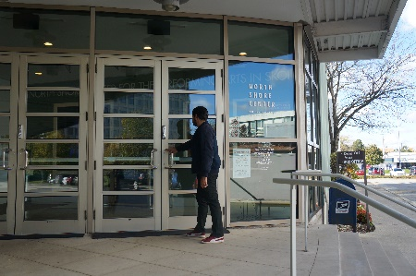 | North Shore Center for the Performing Arts  Entrance  Id: The doors to North Shore’s building. The doors are paneled glass and there is a hand railing leading up. A man is entering the doors.
North Shore Center for the Performing Arts
Parking Lot

Id: The parking lot at the theater. It is a sunny day with many clouds, there is a sign that says “Theatre Parking Only” and several cars parked.
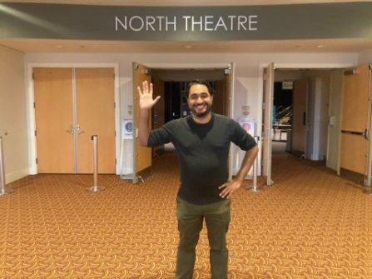 | Northlight’s Auditorium  Id: The doors leading directly into the theater. There are three doors which are all light brown wood. Two doors are open. A sign above the doors reads North Theatre. A man is waving hello.
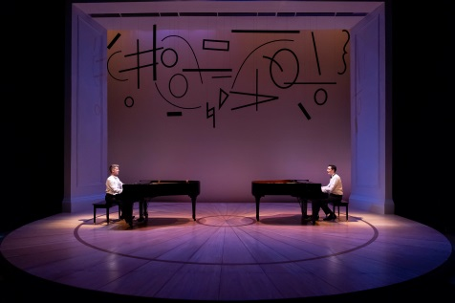 | The Set of 2 Pianos 4 Hands  Id: The set of 2 Pianos 4 Hands. A round, concert hall-like stage with glossy wooden floors and a tall rectangular proscenium made of white molding. Center, two black grand pianos face each other. Above them, there is a jumble of curves, lines, and dots that resemble, abstractly, music notes.
Kristen Waagner
Artistic Programs Manager

Id: A young woman with light skin and dark brown eyes smiles slightly at the camera in front of an olive green wall. Her face is framed by straight black hair, and she wears a light blue tank top.
BJ Jones
Artistic Director

Id: A picture of a jolly older man with a white beard and hair going silver.
Adam LaSalle
Ted

Id: A white man in his 30s looks at the camera with a blank expression. His hair is neat and combed back, and he sports a close-shaved goatee, and an olive-green collared shirt.
Matthew McGloin
Richard

Id: A white man in his 40s smiles warmly at the camera. He is clean-shaven, has short, graying hair combed to one side, and stands in front of a plain, white background.

