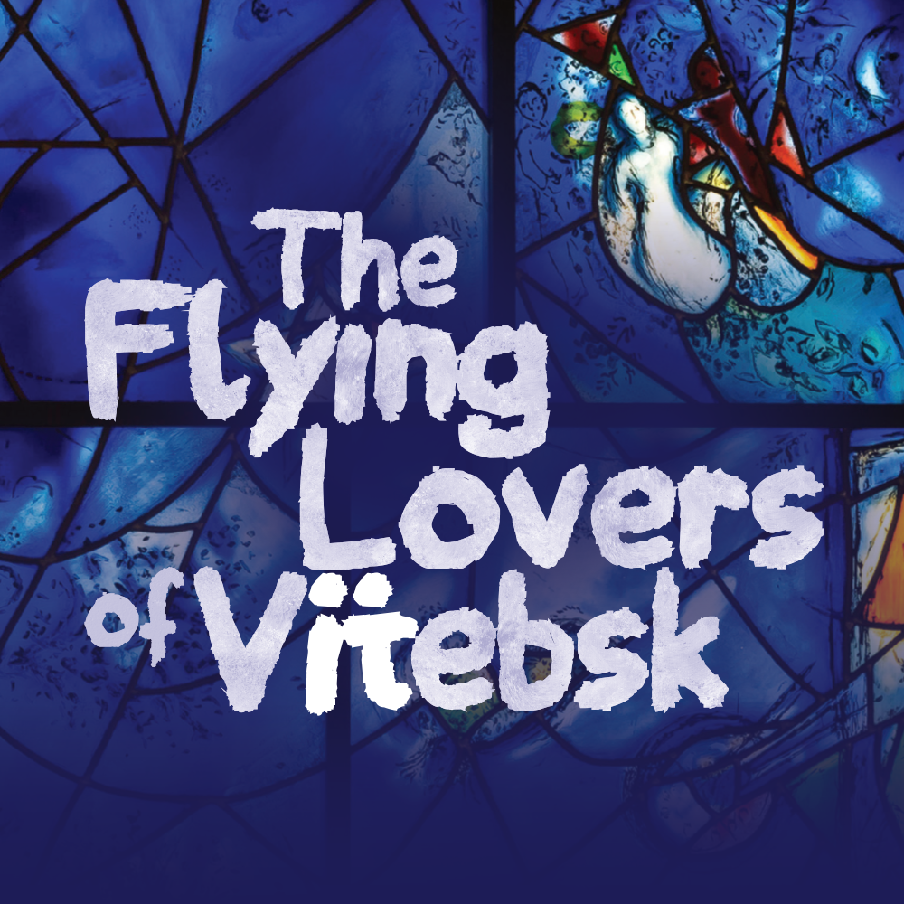

ACCESSIBILITY GUIDE

GUIDE INTRODUCTION

Welcome to Northlight’s production of *The Flying Lovers of Vitebsk* by Daniel Jamieson, with music by Ian Ross.

This production will run at Northlight Theatre from September 5 through October 6, 2024. The address is 9501 Skokie Blvd, Skokie, IL, 60077.

This guide holds many different accessibility tools to make your experience at the show as comfortable as possible. Please be aware that not every element of this guide will be useful to each individual. Accordingly, please feel free to pick and choose which accessibility tools would be most beneficial to you.

TABLE OF CONTENTS

Performance Schedule….……………………………………………………………………pg 3

Synopsis*………………*..………………………………………………………………………………pg 4

Sensitivity Guide.………………………………………………………………………………...pg 8

Frequently Asked Questions………………………………………………………….…pg 9

Reference Photos…………………………………………………………………….………….pg 11

PERFORMANCE SCHEDULE

Tuesday – Saturday Evenings(all times are estimates)

6:30pm The lobby opens for concessions & socializing.

7:00pm The auditorium opens for you to take your seat.

7:30pm The show will begin.

8:50pm The show will end.

Saturday – Sunday Matinees(all times are estimates)

1:30pm The lobby opens for concessions & socializing.

2:00pm The auditorium opens for you to take your seat.

2:30pm The show will begin.

3:50pm The show will end.

Weekday Matinees(all times are estimates)

12:00pm The lobby opens for concessions & socializing.

12:30pm The auditorium opens for you to take your seat.

1:00pm The show will begin.

2:20pm The show will end.

FULL SHOW SYNOPSIS

(spoilers ahead)

*Please note that the following was created during a preview performance. It is possible that changes to the script and/or production may not be reflected below.*

Run time: 80 minutes with no intermission

The play begins with the artist Marc Chagall, now an old man, being interviewed over the phone by a journalist, Franz,who asks pretentious leading questions about Chagall’s art. Franz mentions the motif of the “flying lovers,” and Marc, lost in memory, abandons the conversation. Holding up a postcard, he transports us to his hometown, Vitebsk, in 1914. He describes the various sights, sounds, and smells of home, eventually landing on a memory of his lover, Bella.

Bella, speaking to the audience, recounts her memory of first seeing Marc. She was visiting her friend, Thea, and upon seeing Marc, she felt like his eyes were piercing her. She learned from Thea that Marc was a Jewish painter who needed models for his paintings. He asked to draw her, and they began courting. Soon after, however, he went to Paris to “find greatness.”

We return to Marc, who is celebrating a successful exhibition in Berlin before he returns to Russia for three months to marry Bella. At home, Bella comforts her mother, who is crying because it is Tisha B’av, a Jewish fast day that memorializes several tragedies in Jewish history. She notes that war has been declared, but speculates that it will be over soon. Bella and Marc marry upon his return. They recall the sights, sounds, and colors of their romance. They go on a honeymoon to Bella’s family’s dacha, or cottage, as war breaks out in Europe, and Marc exclaims that he cannot wait to bring Bella to Paris.

In Vitebsk again, Marc attempts to bribe the governor to allow them to travel out of Russia, but he is rebuffed due to the war. At his mother’s house, he meets the Rabbi of Slousk and paints a portrait of him sleeping. Marc is called up to serve in the war, but Bella offers to get him a position in the war office working for her brother in St. Petersburg to avoid the fighting. There, he must work eleven hours a day, while Bella sits at home and waits for him. During those long days, she begins to write in an old notebook. At work, Marc laments the difficulty of the job and the cold in St. Petersburg. Through Marc’s eyes, we experience the February Revolution and the abdication of Tsar Nicholas II; every worker at his office has left, and Marc celebrates a newfound freedom for Jews and the possibility of travel.

However, this time brings violence too. Amidst fleeing soldiers and gunfights in the street, Marc encounters a policeman that has been hanged. He encounters an anti-Semitic gang, but denies being Jewish. They fire a warning shot at him, laughing, and he escapes.

At home, Bella has given birth to a daughter, but is angry because Marc has been absent, focusing only on an upcoming exhibition. They argue; Marc believes his paintings are the only thing that give him worth, but Bella disagrees, asking him to think of their daughter. Marc has been invited to become a Director of Fine Art in the new government, but Bella urges him to go back to Vitebsk, where he might start a small art school. He acquiesces, and learns their daughter’s name – Ida, for his mother.

Back in Vitebsk, Marc speaks to the house-painters of Vitebsk, imploring them to join his art school and commemorate the first anniversary of the October Revolution with painted banners. He is enthusiastic, believing this new government will mean that Russia belongs to the people at last. Bella is more skeptical.

Time passes. Marc reads a scathing review of his banner presentation in a local newspaper. After inviting artists from the Suprematist movement to teach in his art school, they have collectively voted to oust him from the school. Bella rushes in to tell Marc that the Cheka, or secret police, are raiding her parents’ shop, stealing or destroying all of their valuables. She begs Marc to use his influence to stop them, but he is focused on the most important thing to him: painting. He insults Bella, telling her that her myopic focus is the reason she will never be a writer.

The couple leaves Vitebsk for Moscow, not even returning for the funeral of Marc’s father, who was killed by a truck. Marc gets a job painting scenery for the New Jewish Theatre. Bella is enchanted by the actors and the theatre, learning a Yiddish poem from one of them, while Marc tires of it. He receives a letter from his sister, which recounts how all the synagogues in Vitebsk are being closed down. They sing the poem together and share a moment of passion.

Marc hears from Berlin that his paintings have become famous in Germany, launching the Expressionist movement and granting him worldwide recognition. They leave Russia and begin a period of travel, growing older over the next twenty years. Receiving news of Nazi atrocities inspires Bella to begin writing in Yiddish again about their home in Vitebsk.

While staying outside New York, Bella falls ill. She is afraid of the nuns in the hospital, afraid that they will not treat her because she is Jewish. Growing sicker, she asks for her daughter, refusing to let Marc take her to the hospital. Instead, Marc recounts happy moments in their life together.

Marc, now old again, picks up the telephone. He says that Bella died of a streptococcus infection because in wartime, the doctors had no penicillin to give her. After her death, he rediscovered her writing, and worked with their daughter to publish the books and translate them into French. Concluding the interview for the day, he is visited by Bella’s spirit, and they dance together.

SENSITIVITY GUIDE

CONTENT NOTES

* The play centers on Jewish characters that live through the Russian Revolution, World War I, and World War II. There is discussion of war, anti-Semitic violence, and hate as it relates to their lives and their hometown of Vitebsk.
* A character mentions posing as a nude art model.
* A character is threatened by an anti-Semitic gang and a gun is fired at him.
* A character describes a moment when he saw a policeman who had been hanged in the street during a riot. The body is depicted stylistically by another actor.
* A major character dies due to illness.
* Characters use the words “damn” and “hell.”

SENSORY NOTES

* Light haze/fog is used throughout the show.
* A loud gunshot sound is heard following a confrontation, accompanied by a sudden bright flare of white and red light.
* The sound of glass breaking is heard.
* Characters shout amidst an imaginary crowd.
* Characters raise their voices at each other in anger, sadness, and frustration.

FREQUENTLY ASKED QUESTIONS

Does this production contain any technical elements that could be loud, bright, or shocking?

Like many of Northlight’s plays, this production will include technical elements that may trigger sensory sensitivities. Northlight has done its best to design elements so that they will be accessible to all, but each person is different, thereby making it impossible to plan for every individual. If you believe that you may have some sensory sensitivities to the show, please consult the guide above to make you are aware of them before they happen. Please also remember that Northlight has noise canceling headphones as well as sunglasses available to borrow for any of these moments.

What types of accessibility options does Northlight provide?

Northlight provides a wealth of accessibility options for its audience members. These tools can be broken up into two specific categories: Specific Date Accessibility and General Accessibility.

For specific date accessibility, Northlight will provide accommodations on predetermined dates throughout the run. We highly recommend reserving tickets for these dates ahead of time. These accommodations include: Audio Description, Open Captions, and Relaxed/Sensory Friendly Performances.

For general accessibility, Northlight provides a wide range of tools that can be requested at any performance of the show free of charge. These include: assisted listening devices and accessible seating. For accessible seating, it is recommended you request the necessary seats when purchasing your tickets, as they may not be available the day of the performance. For assisted listening devices, please go to the House Manager or ask an usher.

For more information, visit <https://northlight.org/accessibility/> or email <access@northlight.org>.REFERENCE PHOTOS

|  |  |
| --- | --- |
| The front of North Shore Center on a sunny day. The building has white columns and its sides is primarily made of windows. | North Shore Center for the Performing Arts  Exterior  Id: The front of North Shore Center on a sunny day. The building has white columns and its sides are primarily made of windows. |
| The doors to Northshore’s building. The doors are paneled glass and there is a hand railing leading up. A man is entering the doors. | North Shore Center for the Performing Arts  Entrance  Id: The doors to North Shore’s building. The doors are paneled glass and there is a hand railing leading up. A man is entering the doors. |
| The parking lot at the theatre. It is a sunny day with many clouds, there is a sign that says “Theatre Parking Only” and several cars parked. | North Shore Center for the Performing Arts  Parking Lot  Id: The parking lot at the theater. It is a sunny day with many clouds, there is a sign that says “Theatre Parking Only” and several cars parked. |
| The doors leading directly into the theater. There are three doors which are all light brown wood. Two doors are open. A sign above the doors reads North Theatre. A man is waving hello. | Northlight’s Auditorium  Id: The doors leading directly into the theater. There are three doors which are all light brown wood. Two doors are open. A sign above the doors reads North Theatre. A man is waving hello. |
| The set is made up of abstract shapes in gray, upon which light and text is projected. At the center of the stage, there is a ramp with a slight incline that extends offstage. In the background, an unadorned staircase climbs offstage to the right. | The Set for *The Flying Lovers of Vitebsk*  Id: The set is made up of abstract shapes in gray, upon which light and text is projected. At the center of the stage, there is a ramp with a slight incline that extends offstage. In the background, an unadorned staircase climbs offstage to the right. |
| A picture of a jolly older man with a white beard and hair going silver. | BJ Jones  Artistic Director  Id: A picture of a jolly older man with a white beard and hair going silver. |
| Jack Cahill-Lemme's Headshot | Jack Cahill-Lemme  Marc Chagall  Id: An actor in his 20s smiles broadly at the camera. He is white with short brown hair, thick eyebrows, and wears a black shirt against a beige backdrop. |
| Emma is a Caucasian, Jewish female with pale skin, blue eyes, and short brown hair. She’s wearing a blue sweatshirt and a decidedly, erm…intense expression. | Emma Rosenthal  Bella Rosenfeld Chagall  Id: Emma is a Caucasian, Jewish female with pale skin, blue eyes, and short brown hair. She’s wearing a blue sweatshirt and a decidedly, erm… intense expression. |
| A Caucasian guy in his early 40’s with short (thinning) brown hair grins impishly at the camera. He’s got dimples and Micky Mouse crescent moon eyes and one cocked eyebrow (the scamp), and he’s wearing a red jacket over a gray t-shirt in front of an empty gray void. | Michael Mahler  Ensemble  Id: A Caucasian guy in his early 40’s with short (thinning) brown hair grins impishly at the camera. He’s got dimples and Mickey Mouse crescent moon eyes and one cocked eyebrow (the scamp), and he’s wearing a red jacket over a gray t-shirt in front of an empty gray void. |
| A white woman, face angled slightly left to reveal her right ear.  She has a fun, spiky brown faux hawk that tapers down to short shaved hair in the back. She is wearing a maroon shirt, standing against a beige background. She has a big smile on her face that creates a couple of laugh lines next to her brown eyes. | Elisa Carlson  Ensemble  Id: A white woman, face angled slightly left to reveal her right ear.  She has a fun, spiky brown faux hawk that tapers down to short shaved hair in the back. She is wearing a maroon shirt, standing against a beige background. She has a big smile on her face that creates a couple of laugh lines next to her brown eyes. |