

ACCESSIBILITY GUIDE

GUIDE INTRODUCTION

Welcome to Northlight’s production of *Louisa May Alcott’s Little Women*, adapted by Lauren Gunderson from the original by Louisa May Alcott.

This production will run at Northlight Theatre from November 29 through January 12, 2024. The address is 9501 Skokie Blvd, Skokie, IL, 60077.

This guide holds many different accessibility tools to make your experience at the show as comfortable as possible. Please be aware that not every element of this guide will be useful to each individual. Accordingly, please feel free to pick and choose which accessibility tools would be most beneficial to you.

TABLE OF CONTENTS

|  |  |
| --- | --- |
| Performance Schedule | pg 3 |
| Synopsis | pg 4 |
| Sensitivity Guide | pg 10 |
| Frequently Asked Questions | pg 11 |
| The Set of *Louisa May Alcott’s Little Women* | pg 13 |
| Reference Photos | pg 14 |

PERFORMANCE SCHEDULE

Tuesday – Saturday Evenings(all times are estimates)

6:30pm The lobby opens for concessions & socializing.

7:00pm The auditorium opens for you to take your seat.

7:30pm The show will begin.

10:00pm The show will end.

Saturday – Sunday Matinees(all times are estimates)

1:30pm The lobby opens for concessions & socializing.

2:00pm The auditorium opens for you to take your seat.

2:30pm The show will begin.

5:00pmpm The show will end.

Weekday Matinees(all times are estimates)

12:00pm The lobby opens for concessions & socializing.

12:30pm The auditorium opens for you to take your seat.

1:00pm The show will begin.

3:30pm The show will end.

FULL SHOW SYNOPSIS

(spoilers ahead)

*Please note that the following was created during a preview performance. It is possible that changes to the script and/or production may not be reflected below.*

Run time: 2 hours and 30 minutes, with one 15-minute intermission.

**Act I**

When the play begins, we are introduced to a young, excited Louisa May Alcott, who speaks directly to the audience. A publisher has asked her to write a book for girls, and she decides to write down the story of her sisters. One at a time, she introduces them: traditional Meg, spirited Amy, and gentle Beth. They are based on her real-life sisters Anna, May, and Beth. She also introduces her mother, whom they call Marmee. Louisa, who went by the nickname “Lu,” writes herself into the story through the character of Jo. From this point on, the actors alternate between narrating the action and playing their characters.

The story begins at Christmas in 1862, in the Marches’ home in Concord, Massachusetts. While preparing to put on an annual Christmas play, the sisters lament that there will be no presents this year. Marmee returns home, bringing a letter from their father, who is fighting as a soldier in the Civil War. In the letter, he asks them to faithfully do their duty while he is away. Wanting to make amends for their earlier complaining, the sisters help Marmee bring their Christmas breakfast over to their neighbors, the Hummels. The Hummels are a poor family, with a sick mother and six hungry children, and are very grateful for the food.

When the Marches return home, they are surprised to find their table full of food, donated by their neighbor Mr. Laurence. He saw them helping the Hummels, and wanted to show his appreciation for their generosity. To express their gratitude, Beth plays the piano while they all sing “Hark, the Herald Angels Sing.”

Meg and Jo attend a party in town. Though they are both nervous at first, Meg is quickly asked to dance. Jo, however, hides behind a curtain and encounters Laurie, the grandson of their neighbor Mr. Laurence, who is also hiding from the party. They are intrigued by each other, and dance with abandon to a polka in the hall. When Meg reappears with a sprained ankle, Laurie volunteers his grandfather’s carriage to take them home. They arrive safely, impressed by Laurie’s chivalry. Meg notices Laurie’s tutor, Mr. Brooke.

A few days later, Jo spies Laurie looking at her from his window, and comes up to chat with him. She is awed by the Laurences’ library and grand piano. Their friendship flourishes. Mr. Laurence invites Beth to play the piano in their house. Charmed by her music and her gratitude, he gifts her a cabinet piano to keep at the March home, to Beth’s delight.

Jo and Meg are invited by Laurie to see a play, and Amy wants to go with them. Jo denies her, angering Amy. As an act of revenge, Amy burns Jo’s in-progress manuscript, leading to an altercation. Jo slaps Amy and swears to never forgive her.

The next morning, Jo and Laurie go ice skating on the frozen river, and Amy follows, planning to win Jo’s forgiveness. Though she spitefully ignores Amy at first, Jo turns around in time to see Amy fall through the ice into the freezing water. Laurie helps Jo rescue Amy, and they bring her home to warm up. Jo feels guilty for her bout of temper, and with Marmee’s gentle prompting, Jo and Amy reconcile.

It’s summer, and the March and Laurence houses are playing a game of croquet. There is a growing flirtation between Meg and Mr. Brooke, who begins to teach Meg German. Jo strongly disapproves of the budding romance, not wanting a marriage to break up their family.

In autumn, Jo begins to submit stories to the newspaper, and has her first piece published. However, her celebration is interrupted by a letter informing the Marches that their father has fallen ill. Marmee will leave for Washington to be with him. Mr. Brooke gallantly offers to escort her to the capital, and Jo sells her hair to raise some money for the trip.

While Marmee is away, Beth rushes in from the Hummels’ house. She has witnessed the Hummels’ youngest child die of scarlet fever, and the doctor warned her that she might have it too. Jo and Meg have both had the disease before and are immune to infection, but they send Amy, who has never had it, to Aunt March’s house. Beth grows very ill, and Jo sends for their mother, lamenting the fact that she had not done so earlier out of pride. Laurie comforts her, and confides that he has already sent for Marmee; she will arrive later that night. Overcome with gratitude, Jo hugs Laurie, and he kisses her bashfully.

Marmee arrives home, accompanied by Mr. Brooke, and Beth’s health improves. It’s Christmas again, and they are greeted with another surprise: their father returning home. The house is full of joy, and Mr. Brooke – John – asks Meg to marry him. Despite Jo’s urging to refuse him and Aunt March’s disapproval, Meg accepts. Though Jo is unhappy with this decision, she takes a moment to be grateful for all she has.

The characters ask Louisa what will happen next, and she replies that she’ll only write a sequel if people like the first book. We hear that the book has become incredibly popular, sold out in Boston, Chicago, and New York. Louisa takes a breath in to continue the story.

**Act II**

Louisa, writing, tells us that she has finished the sequel in under three months to satisfy her publisher and her fans, who want Jo to marry Laurie. Louisa hates this pressure, and wants Jo to end up a “literary spinster.”

Three years have passed for the March family. Meg has married John, Jo is devoted to her writing, Beth remains delicate after her illness, and Amy spends time with Aunt March. Laurie has gone off to college, where he engages in brief love affairs, but his heart still belongs to Jo. She’s having none of it. Jo wins a story contest with a cash prize, and uses the money to send Beth and Marmee to the seaside. Her stories begin to earn increasing recognition, and she revels in her newfound financial stability.

Aunt March invites Amy to go to Europe with her, making Jo jealous. Amy is thrilled to experience the art and fashion of Europe. Jo, feeling restless, decides to move to New York and teach children in a boarding house. She wants independence, but she also wants to leave Laurie and his increasing romantic attentions behind. When she breaks the news to him, he tries to confess his love to her, but she awkwardly deflects his advances before he can get far.

Jo writes a letter home from New York, telling Marmee and Beth about her new home in the boarding house and an interesting professor from Berlin called Friedrich Bhaer. Jo and Professor Bhaer connect over a poem he is reading and form a friendship, sharing books and going to lectures together. He gives Jo a copy of Shakespeare’s works as a gift. Jo travels home for Laurie’s graduation, and Professor Bhaer sees her off at the station with a bouquet of violets.

Upon Jo’s return, she sees that Beth’s condition has worsened. Meg complains to Marmee of the difficulties of life with a husband and children. Laurie invites Jo to go for a walk with him. There, he emotionally confesses his love for Jo, who responds that she can’t love him or marry him. He accuses her of being in love with Professor Bhaer, but Jo asserts that she and Laurie would not be a good match. Jo announces that she believes she will never marry; she loves her liberty too much.

Heartbroken, Laurie travels to Europe, where he meets Amy in Nice. Amy has been taking art lessons and attending dances, and is torn about whether to return home to be with Beth. Laurie encourages her to stay, and they find comfort in each others’ familiar presence.

Beth plays the piano while Jo listens. Beth says that she’s come to accept her own death, and Jo begs her to hold on. Time moves ahead, and Beth passes away that spring. Amy receives the news by letter in Europe, with Laurie by her side. The family mourns. Marmee encourages Jo to write through her grief.

Laurie and Amy send news of their engagement. Jo reacts with disbelief, though Marmee is unsurprised, and Jo remarks that if Laurie has proposed again, she might have said yes, if only to stave off her deep loneliness. Laurie and Amy return from Europe, revealing that they have married! Though it is awkward at first, Jo and Laurie quickly fall back into their old banter. The reunited sisters catch up joyfully.

A knock at the door signals the arrival of an unexpected guest – Professor Bhaer. He is welcomed in (with some initial hostility from Laurie) and sings with Jo for the family. He begins to visit often, and the sisters exclaim that he intends to marry Jo. She doubts this, especially when he is unexpectedly absent for three days. She believes that he has left without saying goodbye to her.

In a mood, Jo goes into town on a rainy day to run errands, and Bhaer appears with an umbrella, offering to help her carry her packages. They walk together, and he tells her that he has a job waiting for him in California. She cries at the idea of losing him, and he realizes that his feelings for her are reciprocated. They declare their love for each other, and kiss under the umbrella.

Louisa sits alone, having finished her story. Beth appears and congratulates her. May, Anna, and Marmee share their thoughts on the finished book. We hear snippets of the true stories of their lives after the book. The play concludes with Louisa reading the last few lines of the book, in loving tribute to the little women in her life.

SENSITIVITY GUIDE

CONTENT NOTES

* The play takes place in Massachusetts during the 1860s, and one largely absent character is a soldier fighting for the Union in the Civil War.
* Characters kiss onstage.
* During a fight, one character grabs at her sister’s throat and raises a hand to strike her, but is quickly stopped.
* Characters discuss the death of an infant due to scarlet fever.
* A young character dies due to complications from scarlet fever.

SENSORY NOTES

* Characters raise their voices onstage.
* Light music underscores dramatic scenes.
* A clap of thunder is heard loudly.

FREQUENTLY ASKED QUESTIONS

Does this production contain any technical elements that could be loud, bright, or shocking?

Like many of Northlight’s plays, this production will include technical elements that may trigger sensory sensitivities. Northlight has done its best to design elements so that they will be accessible to all, but each person is different, thereby making it impossible to plan for every individual. If you believe that you may have some sensory sensitivities to the show, please consult the guide above to make you are aware of them before they happen. Please also remember that Northlight has noise canceling headphones as well as sunglasses available to borrow for any of these moments.

What types of accessibility options does Northlight provide?

Northlight provides a wealth of accessibility options for its audience members. These tools can be broken up into two specific categories: Specific Date Accessibility and General Accessibility.

For specific date accessibility, Northlight will provide accommodations on predetermined dates throughout the run. We highly recommend reserving tickets for these dates ahead of time. These accommodations include: Audio Description, Open Captions, and Relaxed/Sensory Friendly Performances.

For general accessibility, Northlight provides a wide range of tools that can be requested at any performance of the show free of charge. These include: assisted listening devices and accessible seating. For accessible seating, it is recommended you request the necessary seats when purchasing your tickets, as they may not be available the day of the performance. For assisted listening devices, please go to the House Manager or ask an usher.

For more information, visit <https://northlight.org/accessibility/> or email <access@northlight.org>.

The Set for *Louisa May Alcott’s Little Women*

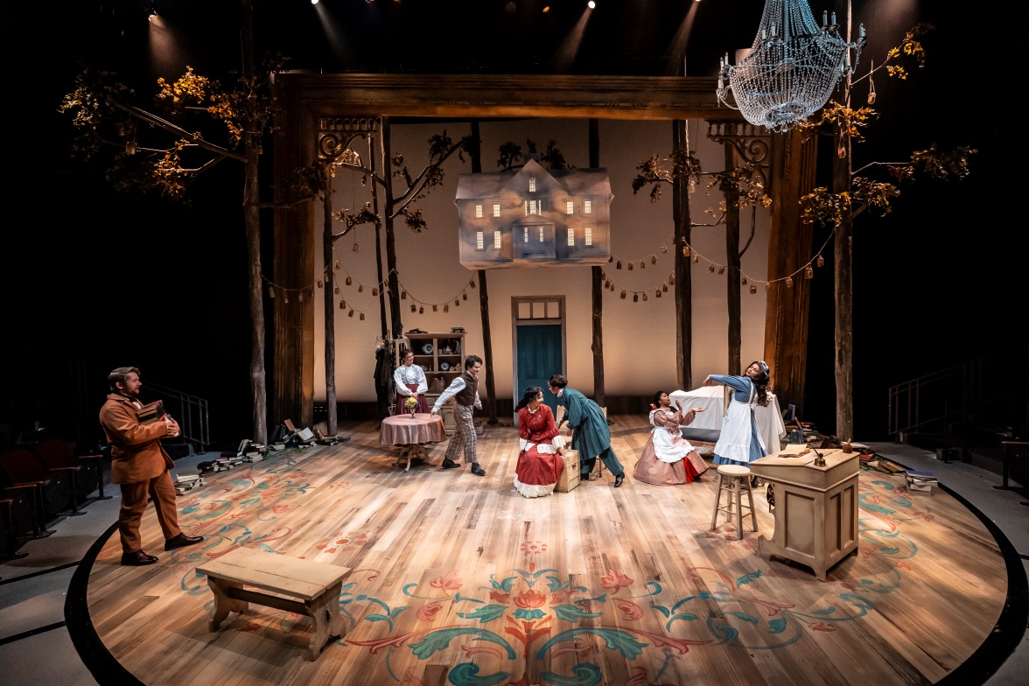

Image Description: Above the stage floats a house, painted like a blue sky with white clouds – a scale replica of Louisa May Alcott’s home, “The Orchard House.” Below, a bench, a writing desk, a dining table, and standing cabinet, all made of the same light-colored wood, evoke the interior of the house. The circular stage floor is covered in light-colored wood planks, and its edges are painted with a pink and blue floral design. In the background, a large, slightly crooked golden picture frame encloses the stage, with a few tall, thin tree trunks visible and a turquoise door at center. Mason jars with candles are strung from the leafy tree branches, and a chandelier hangs from the ceiling slightly off center.

REFERENCE PHOTOS

|  |  |
| --- | --- |
| The front of North Shore Center on a sunny day. The building has white columns and its sides is primarily made of windows. | North Shore Center for the Performing Arts  Exterior  Id: The front of North Shore Center on a sunny day. The building has white columns and its sides are primarily made of windows. |
| The doors to Northshore’s building. The doors are paneled glass and there is a hand railing leading up. A man is entering the doors. | North Shore Center for the Performing Arts  Entrance  Id: The doors to North Shore’s building. The doors are paneled glass and there is a hand railing leading up. A man is entering the doors. |
| The parking lot at the theatre. It is a sunny day with many clouds, there is a sign that says “Theatre Parking Only” and several cars parked. | North Shore Center for the Performing Arts  Parking Lot  Id: The parking lot at the theater. It is a sunny day with many clouds, there is a sign that says “Theatre Parking Only” and several cars parked. |
| The doors leading directly into the theater. There are three doors which are all light brown wood. Two doors are open. A sign above the doors reads North Theatre. A man is waving hello. | Northlight’s Auditorium  Id: The doors leading directly into the theater. There are three doors which are all light brown wood. Two doors are open. A sign above the doors reads North Theatre. A man is waving hello. |
| Tyler, a white female with pale skin, looks directly into the camera with a somewhat serious but mostly whimsical expression. She has green eyes and long auburn hair with bangs. She’s wearing a green dress. | Tyler Meredith  Louisa/Jo  Id: Tyler, a white female with pale skin, looks directly into the camera with a somewhat serious but mostly whimsical expression. She has green eyes and long auburn hair with bangs. She’s wearing a green dress. |
| An actor with curly black hair and brown eyes smiles at the camera. She wears a salmon-colored shirt in front of a white background. | Janyce Caraballo  Meg  Id: An actor with shoulder-length curly black hair and tan skin smiles at the camera. She wears a salmon-colored shirt in front of a white background. |
| An actor with wavy dark brown hair and brown eyes looks seriously at the camera. She wears an emerald-green tank top with a high neck and hoop earrings in front of a blue-gray background. | Yourtana Sulaiman  Amy  Id: An actor with wavy dark brown hair and olive skin looks seriously at the camera. She wears an emerald-green tank top with a high neck and hoop earrings in front of a blue-gray background. |
| An actor with curly black hair tied into an updo and brown skin smiles at the camera. She wears a yellow shirt in front of a pink background. | Demetra Dee  Beth  Id: An actor with curly black hair tied into an updo and brown skin smiles at the camera. She wears a yellow shirt in front of a pink background. |
| A white woman in her 40s sits in a dark blue top. Her bare arms are freckled and a closed mouth smile reveals smile lines around her mouth and eyes. Her wavy hair is down and swept over her right shoulder, mostly dark brown with prominent grey highlights in her bangs. | Lucy Carapetyan  Marmee/Aunt March  Id: A white woman in her 40s sits in a dark blue top. Her bare arms are freckled and a closed mouth smile reveals smile lines around her mouth and eyes. Her wavy hair is down and swept over her right shoulder, mostly dark brown with prominent grey highlights in her bangs. |
| An actor in his 20s stares into the camera with an intellectual expression. He is white with short brown hair, a short brown beard, and wears a blue dress shirt and brown jacket against a green backdrop. | John Drea  Laurie  Id: An actor in his 20s stares into the camera with an intellectual expression. He is white with short brown hair, a short brown beard, and wears a blue dress shirt and brown jacket against a green backdrop. |
| An actor with salt and pepper hair, light skin, and a short, clean-cut beard looks calmly into the camera. He wears a blue-gray T-shirt in front of a dappled dark green background. | Erik Hellman  John/ Friedrich  Id: An actor with salt and pepper hair, light skin, and a short, clean-cut beard looks calmly into the camera. He wears a blue-gray T-shirt in front of a dappled dark green background. |